End to End Demand Forecasting System
Project Goal:
Predict future demand and helps businesses plan inventory and revenue.
- Inventory Planning
- Revenue Planning
- Supply- chain marke

Next 1 – Business Understanding and problem farming

\\ 1. Business Problem:
Given Historical sales data, predict future product demand to help business plan inventory and revenue.
Why this matters:
- Overstock: cash blocked, storage
- Understock: Lost sales, Unhappy Customer
- Forecasting helps planning, not just prediction
\\ 2. Who use this forecast:
In real companies:
- Inventory Manager: how much need to order
- Supply chain team: logistic planning (strategic process of organising movement)
- Finance team: Revenue estimation
So our model must be
- Interpretable
- Stable
- Business friendly
(Not just high accuracy)
\\ 3. What exactly are we predicting?
Target Variable:
- Sales/ Demand (numeric)
- Daily sales quantity
- Monthly unit sold

Time Granularity
- Daily (more detailed, more noise)
- Weekly / Monthly (cleaner trends)

🔮 Forecast Horizon
- Short-term: next 30 Nexts
- Mid-term: next 3–6 months
We’ll aim for 3–6 months forecast.
What makes this “Time series Problem”
Key idea (must be clear in your head):
- ToNext’s demand depends on past demand
- Order of data matters
- Patterns repeat (seasonality)
That’s why:
❌ Random train-test split
✅ Time-based split
Dataset Clarity
Our dataset must have:
- Date column
- Sales / demand column
- Enough history (at least 2–3 years)
- Real-world noise (not toy data)

Dataset we’ll use:
I propose this classic Kaggle dataset type:
Retail Store Sales – Daily Data
- Multiple stores/products
- Clear seasonality
- Widely used in interviews
Examples (type, not link yet):
- Store sales forecasting
- Superstore daily sales
- Retail demand datasets
You’ll later write something like this:
Built an end-to-end demand forecasting system using historical retail sales data to predict future demand, enabling inventory and revenue planning through time-series analysis and forecasting models.
🧠 1. Think Like a Data Scientist (Most Important)
Before code, always ask:
- ❓ What decision will this model help make?
- ❓ What happens if prediction is wrong?
- ❓ Who uses this forecast? (manager, planner, system)

👉 Demand forecasting is not about accuracy only, it’s about planning.
Example:
- Over-forecast → excess inventory → loss
- Under-forecast → stock-out → revenue loss

Next 2 - Dataset selection & Understanding

- Dataset I’ll Use
I’ll use a well-known, real world Kaggle dataset”
- Store Item Demand Forecasting Challenge
(Retail demand forecasting – multiple stores & Products)

Why I choose this dataset::
- Real- world retail data
- Multiple Stores + Items
- Daily sales Strong seasonality
- Ideal for data scientists

- Key Questions:

- What level should we forecast at?
Options:
- Store level (aggregate all products)
- Product level (across stores)
- Store product level
Decision: I’ll start with Store Product level, then aggregate when needed.

- Model:
“For each store and each product, I have a sequence of daily sales
From this history, I want to predict future demand while respecting time order.”

@ Dataset Description:
The objective of this competition is to predict the months of item-level sales data at different store location.

File Description:
- Train.csv: Training Data
- Test.csv: Test data
- Sample_submission.csv: a sample submission file in correct format.
Data field:
- Date: Date of the sale data. There are no holiNext effect or store closure.
- Store: Store ID
- Item: Item ID
- Sales: Number of items at a particular date.

Next 3: EDA
- Daily sales:
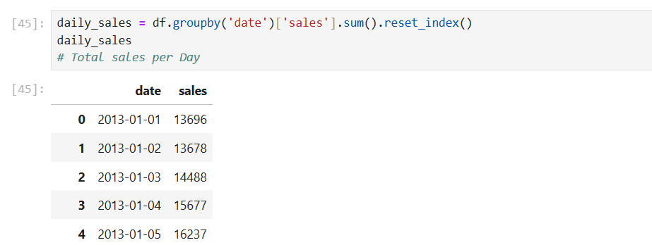

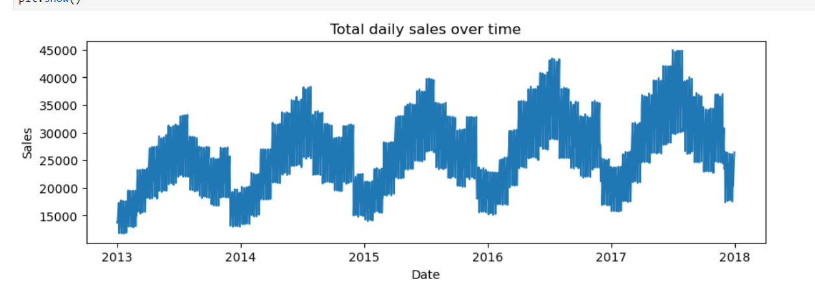
- Sales generally increasing decreasing Trend
- Repeating Ups & Down Seasonality
- Sudden spikes Event/ Noise

  - Since the data shows the trend + seasonality + noise, it is suitable for time series forecasting model such as ARIMA with differencing or prophet, rather than any other techniques.

Next 4: Time series Decomposition
Types of Decomposition
Multiplicative
Additive

We have to check weather data is Additive or Multiplicative

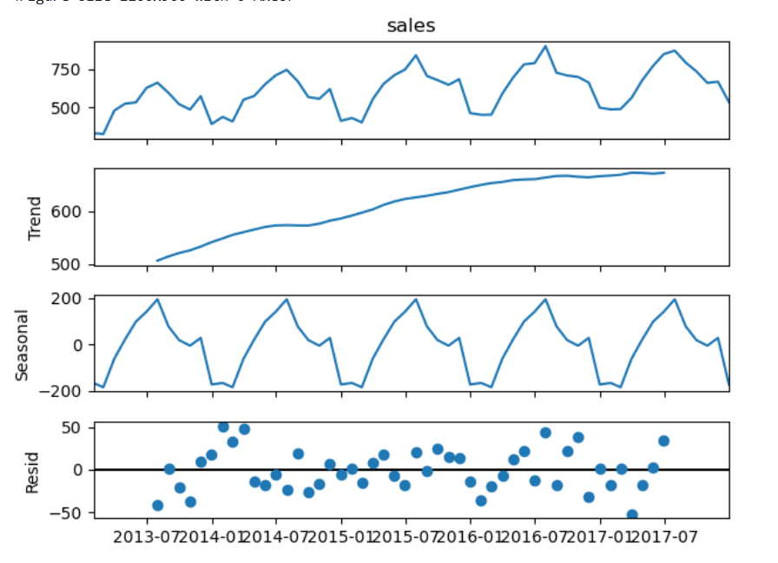
Residual
Seasonal
Trend
Observed

Additive Model:
Sales = Trend + Seasonality + Noise
Multiplicative Model:
Sales = Trend x Seasonality x Noise

Trend: Long Term direction (It either Upword /Downword)
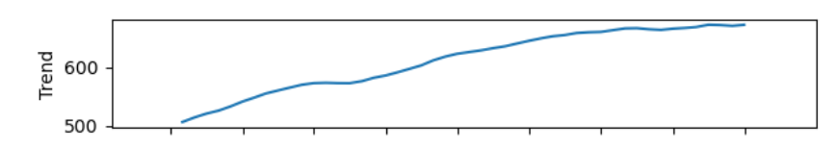
Seasonality: Repeating pattern at fixed interval
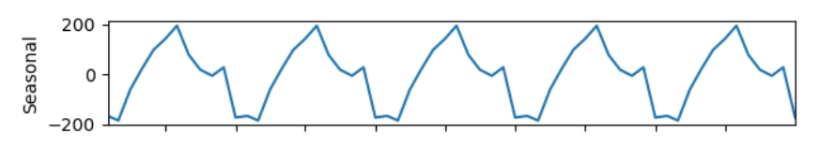
Cyclic: repeating pattern but not fixed interval
Dataset didn’t have Cyclic pattern

Residual/ Noise: Sudden random fluctuation in time series data,
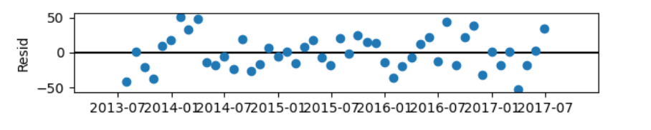

From Plot:
- Seasonal pattern looks similar across the years
Additive Model Is Appropriate

  - I decomposed the time series to confirm the presence of trend and seasonality and to decide the appropriate model structure. The data followed an additive pattern, which informed my choice of forecasting model

Next 5: Train – Test split for Time Series
- Train on Historical data
- Test on last 6 Months

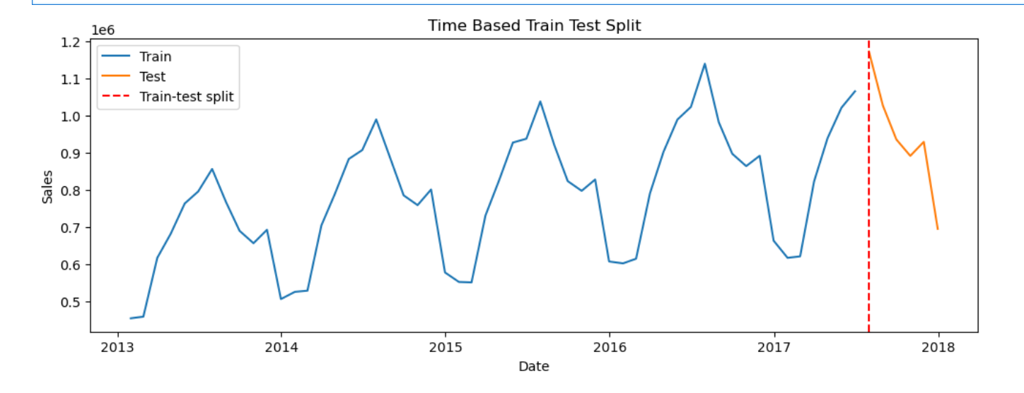
- Train – Past Data
- Test – Future Data
- Clear split line

  - I used time-based split where the model is trained on historical data and evaluated on the most recent months to simulate real world forecasting and avoid data leakage.

Next 6: Baseline Model
Since the data is monthly & seasonal
- Predict future using recent past behaviour
Moving Average Baseline:
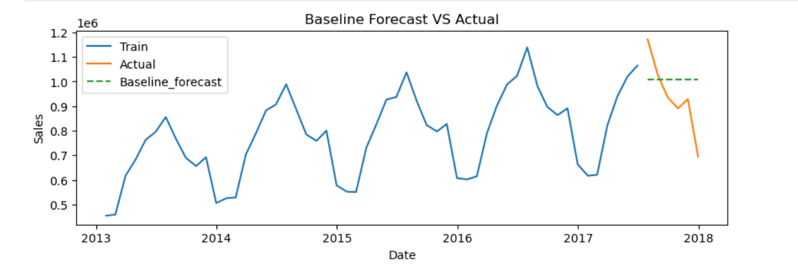
  - Firstly I build the moving average baseline to establish a benchmark. All advanced models were evaluated against this baseline to ensure real improvement.

  - I used rolling mean baseline where the forecast is the average of the most recent three months of training data. This provides a simple benchmark that capture recent demand behaviour and allows me to evaluate whether more complex models offer real improvement.
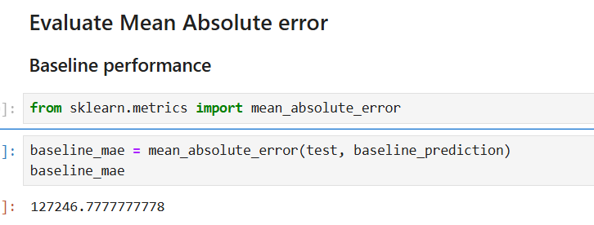
  - This code builds a simple moving average baseline that uses the recent past to predict future demand and serves as a benchmark for advanced forecasting models.
Next 7: ARIMA MODEL
(Auto Regressive Integrated Moving Average)
ARIMA predicts the future values using past values, past error and difference to remove trends.
- AR (p): Uses past values
- I (d) : Differencing to remove trends
- MA (q): Uses past forecast errors
ARIMA Handles:
- Trend (Via differencing )
- Time dependency
- Structured patterns better than baseline

Baseline Model & ARIMA Model Result:
Baseline Model Performing better than ARIMA Model
  - That indicates that the statistical model is not well specified. In my project, the baseline outperformed the initial ARIMA model due to the strong seasonality and untuned parameter, which justified the use of more advanced or seasonal model.

Since ARIMA Model Fails, Now I’m Using Prophet Model

Next 8: Prophet Model
Prophet model is a time series forecasting model developed by Meta.
“A forecasting model that automatically handles the trend, seasonality & holiNext with minimal tuning”
Prophet breaks time series into:
Y(t) = Trend + Seasonality + HoliNext + Error
- Split the data into Train & test
- Fit the train & test in prophet model
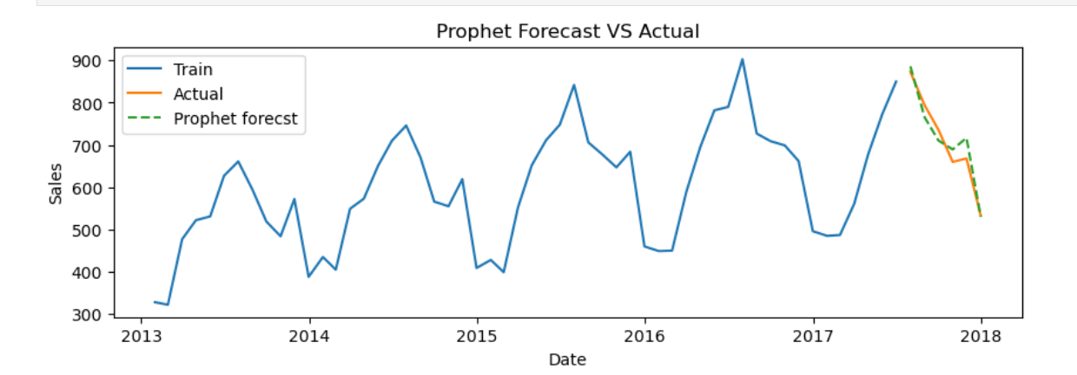
Blue line: Train
- Represents the historical monthly sales for store 1 – item 1
- Shows clear seasonal pattern
Orange line: Actual(Test)
- Represents the true sales value for the test period (last 6 months)
- These are the values model never seen during training
Green Dashed line: Prophet prediction
- Represents sales predicted by prophet model for same test period
- Closely follows the orange (Actual) line
- Captures:
The downward seasonal movement
The overall demand level

🧠 Key Observations (Important)
- Strong alignment between forecast and actual values
→ Prophet predictions are very close to real sales.
- Seasonality is well captured
→ The model correctly predicts the decline after the peak period.
- Small deviations are present
→ These represent normal forecasting error (reflected in MAE ≈ 25).
- No systematic over-forecasting or under-forecasting
→ Errors are balanced, indicating a well-fit model.
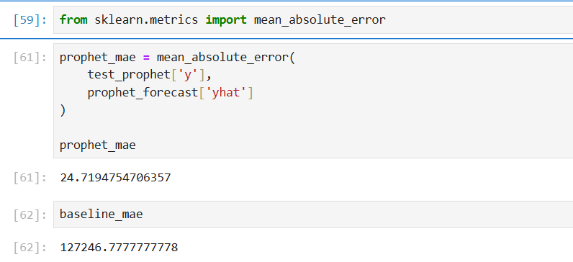
  - After comparing a moving-average baseline, ARIMA, and Prophet models on monthly store–item sales, Prophet Model significantly performed better than others due to its ability to automatically model seasonality and trend, achieving the lowest MAE

  - The Prophet forecast closely tracks the actual sales during the test period, indicating that the model successfully captured both trend and seasonality. Minor deviations reflect normal forecasting error
Prophet is a time-series forecasting model designed for business applications.
It explicitly models trend and seasonality and is robust to noise and missing values.

Next 9: Model Comparison
Model | Performance
Baseline | Weak
ARIMA | Poor
Prophet | Best

Prophet is selected as the final model due to its accuracy and interpretability.

Business Insights and Conclusion

Key insights from this project:
- Demand exhibits strong seasonality and trend
- Simple baselines are insufficient for accurate forecasting
- Prophet effectively captures demand patterns and provides reliable forecasts
Business Impact
The forecasting system can support:
- Inventory planning
- Demand-driven procurement
- Revenue forecasting
This project demonstrates an end-to-end time-series forecasting workflow suitable for real-world applications.

Next 10: @ What is the Output of Project?
The project outputs a time-series demand forecast along with visualizations and business insights that can be used for inventory and demand planning.
Technical Output
- A trained **Prophet time-series forecasting model** that predicts future demand based on historical sales data.
- Forecasted demand values for future dates at the **store–item level**.
- Quantitative evaluation using **Mean Absolute Error (MAE)** to compare models.
Visual Output
- Time-series plots showing:
- Historical sales (training data)
- Actual sales (test data)
- Forecasted sales using the Prophet model
Business Output
- Identification of strong **seasonality and trend** in retail demand.
- Selection of **Prophet as the final model** due to superior accuracy and robustness.
- Inventory planning
- Demand-driven procurement
- Revenue forecasting
Final Conclusion
The project successfully demonstrates an end-to-end demand forecasting workflow.
By combining data preparation, exploratory analysis, model comparison, and business interpretation, the final solution provides reliable demand forecasts that can support real-world retail decision-making.

